
Explainable AI Framework for Employee Attrition Prediction

Project Group Members
S.No. | Roll No. | Student Name
1 | 2420090022 | Ch. Charan Teja
2 | 2420030679 | G. Nishanth
3 | 2400090182 | Moksha
4 | 2420090095 | Mahith

ABSTRACT
Employee attrition is a significant challenge for organizations because the loss of skilled employees can increase recruitment costs, reduce productivity, and affect organizational continuity. This project proposes an Explainable AI framework for employee attrition prediction using machine learning models, with XGBoost as the primary predictive approach. The framework includes data preprocessing, feature engineering, class imbalance analysis, model training, validation, and performance evaluation. SHAP and LIME are integrated to provide global and local explanations, enabling users to understand the factors influencing overall attrition patterns and individual predictions. The expected outcome is a reliable and transparent decision-support framework that predicts employee attrition and identifies key factors that may support employee retention strategies.

Keywords
• XGBoost – Attrition prediction model
• Scikit-learn – Data preprocessing and model evaluation
• SHAP – Global feature explanations
• LIME – Individual prediction explanations
• SMOTE – Class imbalance handling
• FastAPI – API/backend deployment
• GitHub – Version control and project repository

1. INTRODUCTION

1.1 Background
Employee attrition refers to the process through which employees leave an organization. High attrition can increase recruitment and training costs, cause loss of organizational knowledge, reduce productivity, and create workforce planning challenges. Human resource analytics increasingly uses data-driven approaches to understand employee behavior and identify factors associated with attrition. Machine learning can analyze multiple employee-related variables and predict the likelihood of attrition.

1.2 Problem Statement
Existing employee attrition prediction approaches can generate useful predictions, but many models provide limited explanation of how and why a prediction is produced. This lack of transparency can reduce trust and make it difficult for HR professionals to use predictions in decision-making. Therefore, there is a need for a framework that combines employee attrition prediction with transparent explanations, reliability evaluation, and identification of important attrition factors.

1.3 Research Gap
A key limitation in existing studies is the reliance on a single benchmark dataset, which can limit generalizability. Several approaches focus mainly on prediction accuracy without combining global and individual-level explainability. Class imbalance may also affect model reliability, while some studies provide limited validation across datasets. These limitations indicate the need for an integrated framework that evaluates predictive performance, reliability, generalizability, and explainability.
- Limited Generalizability: Most studies rely heavily on the IBM HR Analytics dataset, making it difficult to confirm whether the models perform effectively across different organizations and workforce environments.
- Limited Explainability: Several existing approaches focus primarily on prediction accuracy and model comparison, without providing sufficient explanations for individual employee predictions.
- Lack of Actionable Insights: Existing models mainly identify employees who are likely to leave but provide limited guidance on which factors should be addressed to reduce attrition.
- Class Imbalance Challenge: Employee attrition datasets often contain significantly fewer employees who leave compared with those who stay, which can affect prediction performance.
- Limited Real-World Validation: Many approaches are evaluated on benchmark or synthetic datasets rather than validated using diverse real-world organizational data.

Objective-wise justification
Objective | How your project satisfies it | Project Module / Evidence
1. Develop a framework to predict employee attrition | Employee data is collected, preprocessed, and prepared as input for the ML model. The next XGBoost module will predict whether an employee is likely to leave. | Dataset → Preprocessing → XGBoost → Leave/Stay Prediction
2. Improve model generalizability | The model can be evaluated using appropriate datasets and validation approaches such as train-test split and cross-validation. | Train-test split + Cross-validation + Dataset evaluation
3. Integrate Explainable AI | After prediction, SHAP and LIME will explain which features influenced the result. | XGBoost → SHAP/LIME → Explanation
4. Identify key factors contributing to attrition | Feature importance and SHAP analysis identify factors influencing employee attrition. | Feature analysis + SHAP global importance
5. Enhance prediction reliability | Your preprocessing code already checks class distribution and applies SMOTE only to training data. Model performance will then be measured using multiple metrics. | SMOTE + Precision + Recall + F1 + ROC-AUC + Confusion Matrix

1.4 Research Objectives
- To develop a framework utilizing machine learning models to predict whether an employee is likely to leave the organization.
- To improve model generalizability by evaluating the framework using appropriate datasets and validation approaches.
- To integrate Explainable AI techniques to provide transparent explanations for individual employee attrition predictions.
- To identify the key factors contributing to employee attrition and provide actionable insights for reducing employee turnover.
- To enhance prediction reliability by addressing class imbalance and evaluating model performance using suitable metrics.

1.5 Research Questions
- How effectively can machine learning models predict employee attrition?
- How can model generalizability be evaluated using appropriate datasets and validation approaches?
- How can SHAP and LIME improve transparency for employee attrition predictions?
- Which employee-related factors contribute most to attrition according to the developed model?
- How do class imbalance handling and different evaluation metrics affect prediction reliability?

1.6 Contributions
- An integrated framework for employee attrition prediction using machine learning.
- Integration of SHAP for feature contribution analysis and LIME for individual prediction explanations.
- A validation-oriented approach to assess model generalizability and reliability.
- Identification of important attrition-related factors to support HR decision-making.
- Performance evaluation using Precision, Recall, F1-Score, ROC-AUC, and Confusion Matrix.

1.7 Organization of the Paper
Section 1 introduces the research background, problem statement, research gap, objectives, research questions, and contributions. Section 2 reviews related work on existing employee attrition prediction approaches, machine learning methods, deep learning methods, and explainability techniques. The subsequent sections will describe the proposed methodology, implementation, experimental evaluation, results, discussion, and conclusions.

2. RELATED WORK

2.1 Existing Approaches
1. IBM Employee Attrition Analysis — Yang & Islam (2020)
Yang and Islam (2020) analyzed employee attrition using the IBM HR Analytics dataset. They used Correlation Matrix, Random Forest, K-Means Clustering, and Logistic Regression techniques. The study focused on identifying the major factors influencing employee attrition and understanding why employees leave an organization. However, the study used only a single IBM dataset, which may limit the generalizability of its findings to other organizations.
2. Predict Employee Attrition Using Multiple Machine Learning Techniques — Ghanem & Al-Alawi (2024)
Ghanem and Al-Alawi (2024) compared several machine learning techniques for employee attrition prediction. The study used Random Forest, XGBoost, Decision Tree, Bernoulli Naive Bayes, KNN, SVM, and Logistic Regression. It also considered oversampling and GridSearchCV to improve model development. The objective was to identify an effective machine learning model for attrition prediction, but class imbalance and limited generalization remained limitations.
3. Employee Attrition Prediction Using Machine Learning: A Data-Driven Approach for Workforce Analytics (2025)
This study used multiple machine learning algorithms including Logistic Regression, Gradient Boosting, Random Forest, SVM, and Gaussian Naive Bayes. Feature engineering was also used to prepare employee characteristics for prediction. The main purpose was to predict employee attrition and identify employee characteristics that could help HR managers develop retention strategies. The study primarily focused on prediction and model comparison, while broader real-world validation was identified as an area needing further work.
4. A Stacking Ensemble Framework for Predicting Employee Turnover: Explainable AI with SHAP — Rahman et al.
Rahman et al. proposed a stacking ensemble approach for predicting employee turnover. The study combined Machine Learning, Ensemble Learning, Deep Learning, Stacking, and SHAP techniques. Its purpose was to improve employee turnover prediction while explaining the model's predictions using SHAP. However, the study relied on the IBM HR Analytics dataset, which limits its generalizability to different organizations and workforce environments.
5. Integrating Machine Learning and Explainable AI for Employee Attrition Prediction in HR Analytics (2026)
This study combined Machine Learning, SHAP, Feature Selection, Data Balancing, and Hyperparameter Optimization. The main objective was to achieve accurate employee attrition prediction while providing explanations that HR teams could understand. The approach focuses on identifying the factors behind model predictions rather than providing only a prediction result. However, the use of datasets such as IBM HR Analytics may not fully represent real-world organizations, and SHAP may not capture every complex feature interaction.

6. Employee Attrition Prediction Using Bayesian Optimized Stacked Ensemble Learning and Explainable AI — Konar et al. (2025)
Konar et al. developed an employee attrition prediction approach using Stacking, XGBoost, Random Forest, Bayesian Optimization, SHAP, and LIME. The study aimed to improve attrition prediction and explain why employees were predicted to leave. The use of both SHAP and LIME provides different perspectives for understanding model predictions. However, the approach was mainly evaluated using benchmark data, so broader organizational validation is still required.
7. Integrating Machine Learning and Explainable AI for Employee Attrition Prediction in HR Analytics — Al-Ali et al. (2026)
Al-Ali et al. used Adaptive Boosting, Histogram Gradient Boosting, SHAP, feature selection, and data balancing for employee attrition prediction. The study aimed to combine accurate prediction with explainability, fairness, and actionable HR insights. The approach attempts to make machine learning predictions more useful for HR decision-making. However, existing HR datasets may not fully represent different real-world organizations.
8. Explainable AI for Employee Turnover Prediction: A SHAP-Based Intelligent Analytics Approach — Haojie Jia (2026)
Haojie Jia used XGBoost, Random Forest, LightGBM, Logistic Regression, SHAP, SMOTE, and a fairness audit for employee turnover prediction. The study aimed to provide global, local, and interaction-based explanations for employee turnover predictions. SMOTE was used to address class imbalance, while SHAP was used to understand feature contributions. A limitation is that feature importance and subgroup effects can vary between datasets, requiring validation for different deployments.
9. Predicting Employee Attrition: XAI-Powered Models for Managerial Decision-Making (2025)
This study applied a Transformer model, GAN-based oversampling, and SHAP for employee attrition prediction. The purpose was to address class imbalance while providing explainable predictions that could support HR managers. The approach combines advanced machine learning with Explainable AI to make predictions more useful for managerial decisions. The authors identified the need for validation across more industries and for lightweight real-time implementation.
10. Employee Attrition Prediction: An Explanatory and Statistically Robust Ensemble Learning Model (2026)
This study used SHAP, LIME, Optuna, Random Oversampling, and Ensemble Learning techniques. The main objective was to combine accurate employee attrition prediction with both global and local explanations. The approach also identifies factors that may be important for employee retention strategies. However, because benchmark datasets were used, further real-world organizational validation is still important.

2.2 Machine Learning Approaches
Machine learning approaches include Logistic Regression, Decision Trees, Random Forest, Support Vector Machines, K-Nearest Neighbors, Naive Bayes, Gradient Boosting, and XGBoost. Ensemble methods can improve predictive performance but may reduce interpretability. In this project, XGBoost is used as the primary predictive model, while Scikit-learn supports preprocessing, validation, and performance evaluation.

2.3 Deep Learning Approaches
Deep learning approaches can model complex nonlinear relationships and interactions within employee data. Neural networks may be useful when large and diverse datasets are available, but they can require greater computational resources and may be more difficult to interpret. In HR applications, predictive performance must be balanced with transparency.

2.4 Explainability / Existing Techniques
Explainable AI techniques make machine learning predictions more understandable. SHAP estimates feature contributions and can provide global and local explanations. LIME focuses on local interpretability by approximating model behavior around an individual prediction. Together, SHAP and LIME can provide complementary perspectives for understanding employee attrition predictions.

2.5 Critical Comparison
Approach | Strength | Limitation | Need in Proposed Work
Traditional Statistical Methods | Simple and interpretable | Limited complex pattern analysis | Use ML for complex relationships
Single ML Model | Provides attrition prediction | May lack transparency and broader validation | Add explainability and validation
Ensemble ML | Often improves predictive performance | Can be difficult to interpret | Use SHAP and LIME
Deep Learning | Captures nonlinear relationships | Higher complexity and lower interpretability | Balance accuracy with transparency
Explainable AI | Improves understanding | May provide only limited analysis | Combine global and individual explanations

2.6 Research Gap
The review indicates that employee attrition research has progressed from traditional statistical analysis to machine learning, ensemble learning, deep learning, and explainable AI. However, a combined framework that simultaneously emphasizes prediction, generalizability evaluation, individual-level transparency, key-factor identification, class imbalance handling, and multi-metric reliability evaluation remains a practical research need. The proposed project addresses this gap by integrating XGBoost-based prediction with SHAP and LIME explanations and evaluating the framework using suitable validation and performance measures.

Datasets :
Dataset | URL Link
IBM HR Analytics Employee Attrition | https://www.kaggle.com/datasets/pavansubhasht/ibm-hr-analytics-attrition-dataset
HR Employee Attrition | https://www.kaggle.com/datasets/itssuru/hr-employee-attrition
Employee Attrition Prediction | https://www.kaggle.com/datasets/ziya07/employee-attrition-prediction-dataset

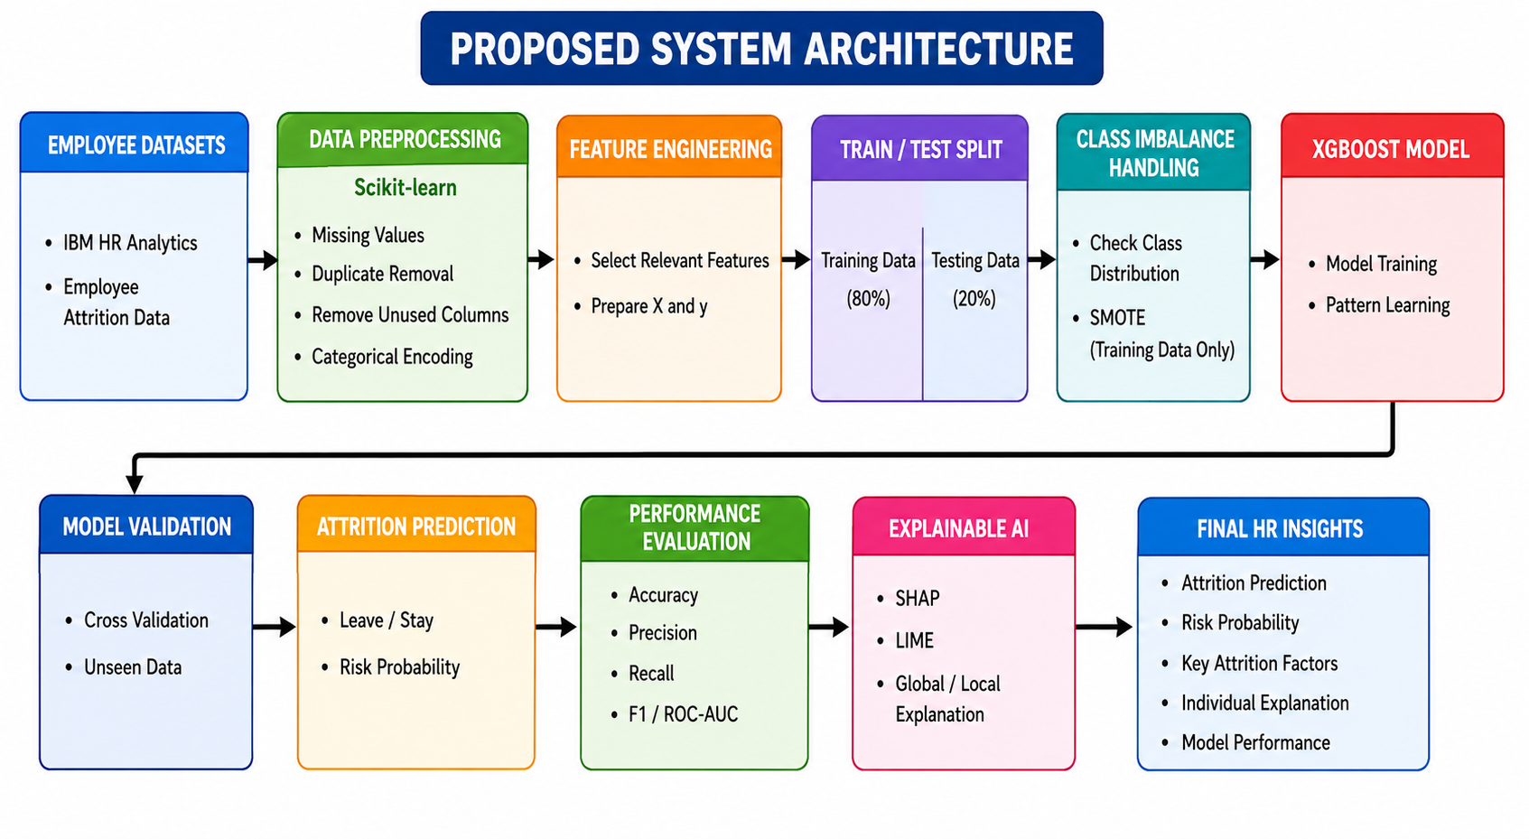

PROPOSED SYSTEM ARCHITECTURE

┌───────────────────────────────┐
│ EMPLOYEE DATASETS │
│ │
│ • IBM HR Analytics │
│ • Employee Attrition Data │
└───────────────┬───────────────┘
│
▼
┌───────────────────────────────┐
│ DATA PREPROCESSING │
│Scikit-learn │
│ • Missing Values │
│ • Duplicate Removal │
│ • Remove Unused Columns │
│ • Categorical Encoding │
└───────────────┬───────────────┘
│
▼
┌───────────────────────────────┐
│ FEATURE ENGINEERING │
│ │
│ • Select Relevant Features │
│ • Prepare X and y │
└───────────────┬───────────────┘
│
▼
┌───────────────────────────────┐
│ TRAIN / TEST SPLIT │
│ │
│ Training Data │ Testing Data │
└───────────────┬───────────────┘
│
▼
┌───────────────────────────────┐
│ CLASS IMBALANCE HANDLING │
│ │
│ • Check Class Distribution │
│ • SMOTE (Training Data Only) │
└───────────────┬───────────────┘
│
▼
┌───────────────────────────────┐
│ XGBOOST MODEL │
│ │
│ • Model Training │
│ • Pattern Learning │
└───────────────┬───────────────┘
│
┌───────┴────────┐
│ │
▼ ▼
┌───────────────────┐ ┌───────────────────┐
│ MODEL VALIDATION │ │ ATTRITION │
│ │ │ PREDICTION │
│ • Cross Validation│ │ • Leave / Stay │
│ • Unseen Data │ │ • Risk Probability│
└─────────┬─────────┘ └─────────┬─────────┘
│ │
▼ ▼
┌───────────────────┐ ┌───────────────────┐
│ PERFORMANCE │ │ EXPLAINABLE AI │
│ EVALUATION │ │ │
│ • Accuracy │ │ • SHAP │
│ • Precision │ │ • LIME │
│ • Recall │ │ • Global / Local │
│ • F1 / ROC-AUC │ │ Explanation │
└─────────┬─────────┘ └─────────┬─────────┘
│ │
└──────────┬───────────┘
│
▼
┌───────────────────────────────┐
│ FINAL HR INSIGHTS │
│ │
│ • Attrition Prediction │
│ • Risk Probability │
│ • Key Attrition Factors │
│ • Individual Explanation │
│ • Model Performance │
└───────────────────────────────┘

